Influencer Analysis- Case Study

BY Mukhtar Khan

1. **Problem Statement :**

* **Description:**
* You have a total of 3 files: Base Data, Tweets Data, and Pricing Data.
* Data dictionary is given in a sheet as well.
* **Tasks:**
* How will you rank the influencers?
* What are the different metrics that should be considered while assessing the quality of influencers?
* Design a scoring mechanism to rank the influencers.
* Given the pricing, design a campaign which will minimize the cost per 1000 followers.
* What changes will you make to the above campaign if quality of influencers is also taken into account?

1. **Tasks Analysis :**

* **How will you rank the influencers?**
* As to give rank to Influencers many metrics should consider i.e. Number of Follower, Number of Tweets, Count of Influencer, Number of People reacting to that Tweets, etc.
* Steps to Performs Analysis to give Ranks to Influencers:
* We first check which Influencers have how many Followers.
* First we plot twitter_handle variable, Tweets_count, Followers_count variable. From Base Data Dataset

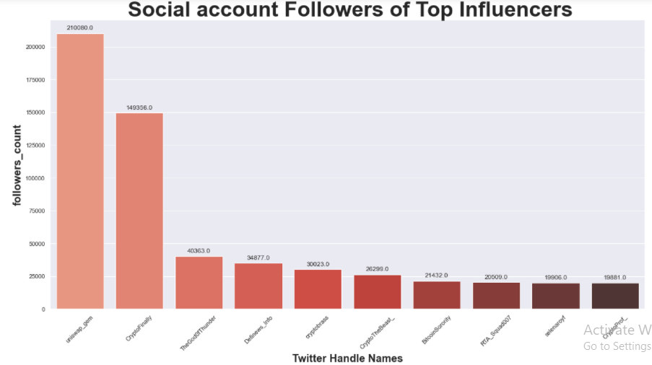

* As we can see Uniswap_gem(influencer) twitter account have highest Followers and follow by CryptoFinally(influencer) twitter account.
* Lets check number Tweets count done by Influencers.

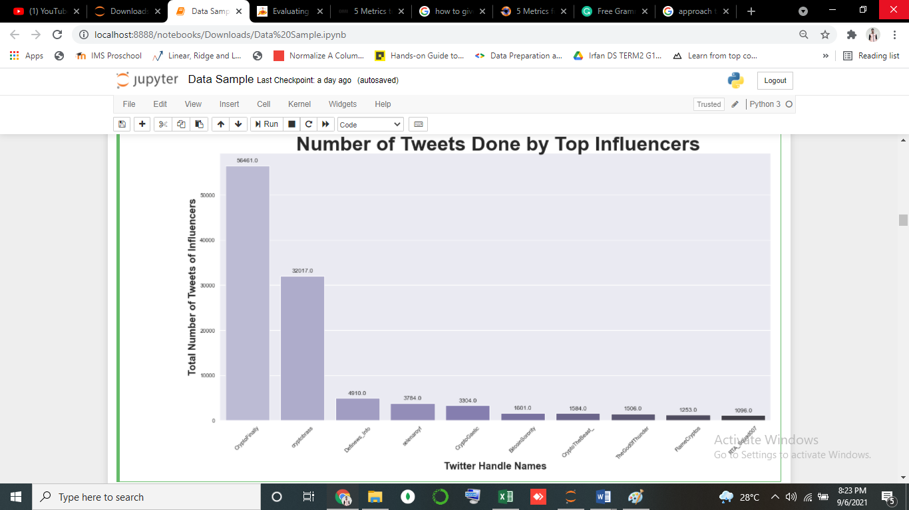

* For the above Graph, we can see that there is some other Influencer (CryptoFinally) who have a high number of Tweets. Compare to that Influencer who has the highest number of followers.
* Let's see if there is a correlation between the Actual Cost (money) given to Influencer against the Followers count they have. To make this graph.
* First we need to merge two Datasets i.e Base Data & Pricing Data. To Merges, these datasets Use the Merge method to perform these tasks.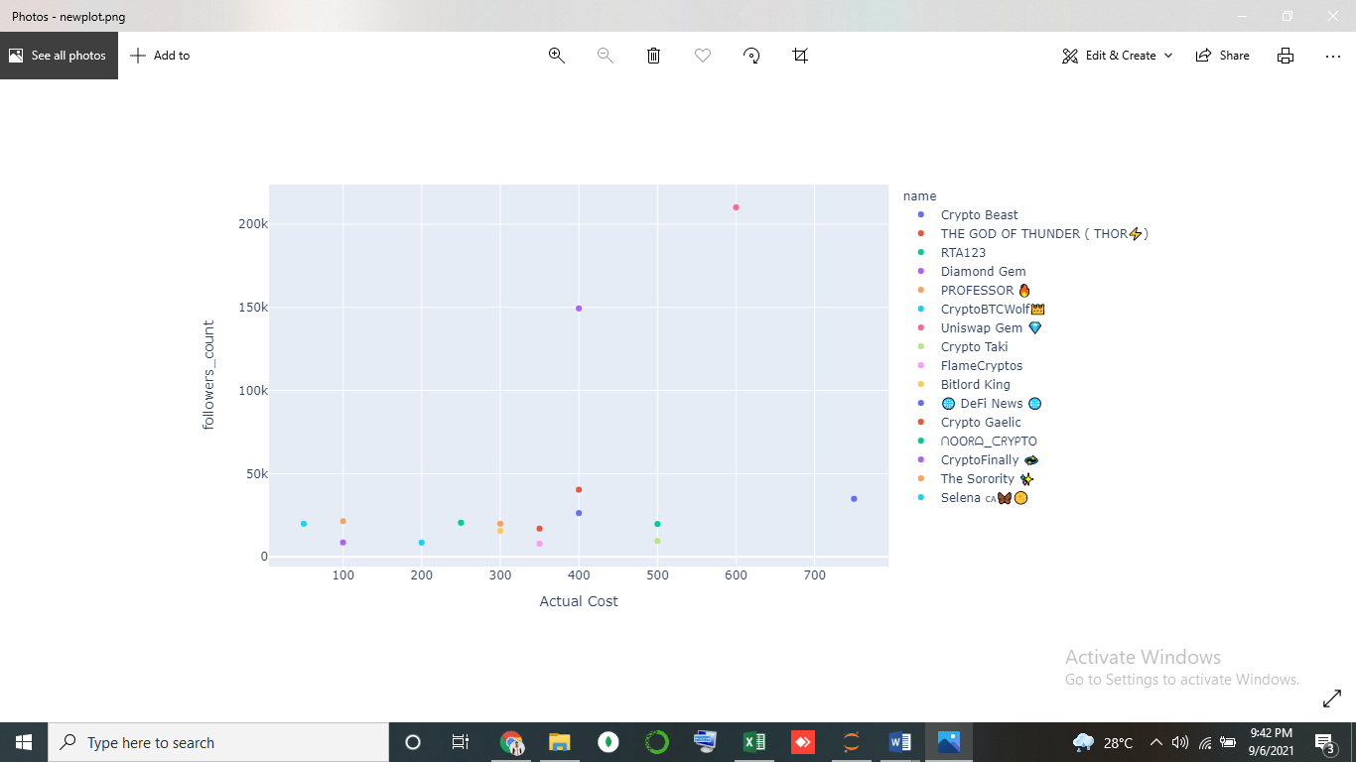
* From the above graph, we can tell that there is a correlation between Actual Cost and Followers. Influencers who have fewer followers they tend to take less charge/pay (their marketing cost is less) compare to less influencer which has high followers.
* To rank the Influencers, We should also check how many followers react on there tweets. We use Tweets data worksheets.

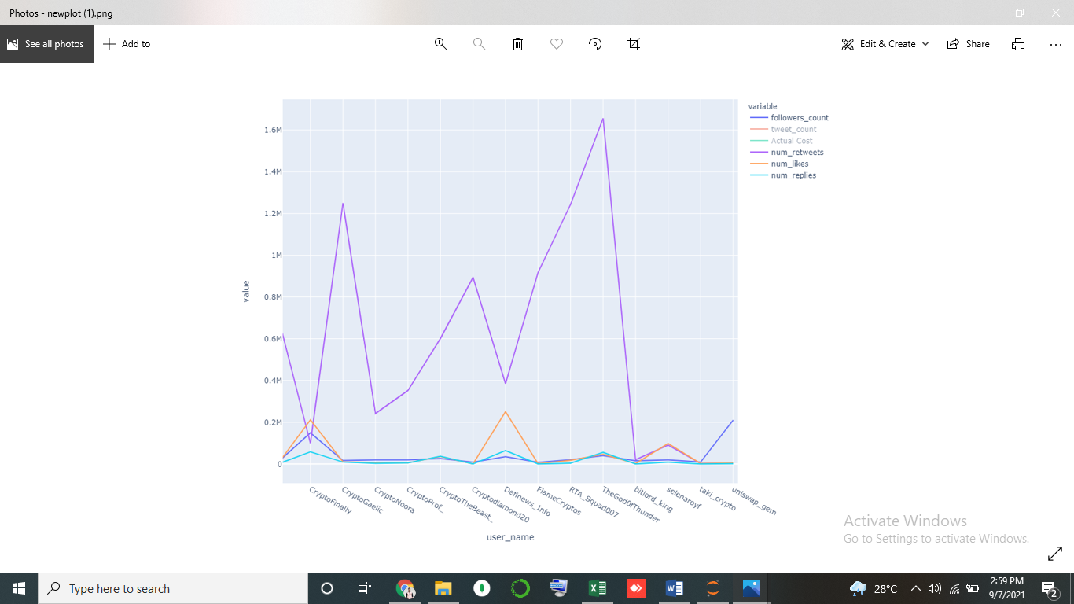

* As shown in the graph, the Influencer (TheGodofThunder) has maximum retweets on his tweet follow by CryptoGaelic.
* For a maximum number of likes, Definews_info has it.
* As the above task asks us to rank the influencers.
* To rank them there are many different metrics we can take into consideration and can rank them in many categories. But to find the best top influencers we take few metrics which help organizations to find the best and with affordable cost.
* As for influencers their follower's number matters for brands to approach them.
* And as for brands they see the engagement of influencer's posts.
* So after seeing all the above graphs we can say that we cannot just hire influencers for campaigns that have the highest followers if he/she is not getting engagement from Followers.
* After checking follower count, we have checked the number of tweets done by influencers and the Cost they charge.
* There are many metrics we can rank influencers.
* **Method** **1** (**Number of retweets per tweet**):
* For ranking, we rank Influencers by the Number of Retweets they get per tweet. Define Conversation Rate, Because you need to be "social" on social media.
* Creating this variable we have taken the Number of replies divided by the total number of Tweets count.
* Then rank in Sorted order
* The reason to use the Number of Retweets variables to rank influencers is that we say that more number of People/Followers

Likes his/her post.

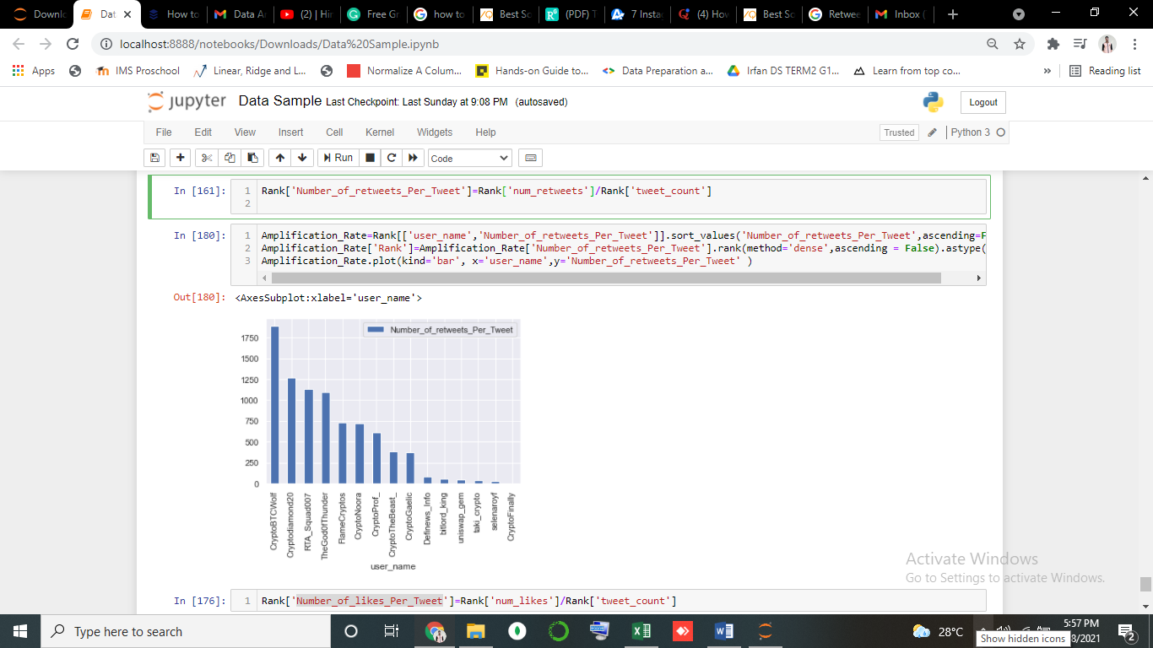

* **Method 2 (Ranking after calculating Number of likes per tweet of influencers):**
* To rank Influencers with Number of likes per tweet.
* From getting Number of likes per tweet we use Number of likes divided by Total number of tweet
* Likes get per post is metrics that is important that show audience interest & they like influencers contents.

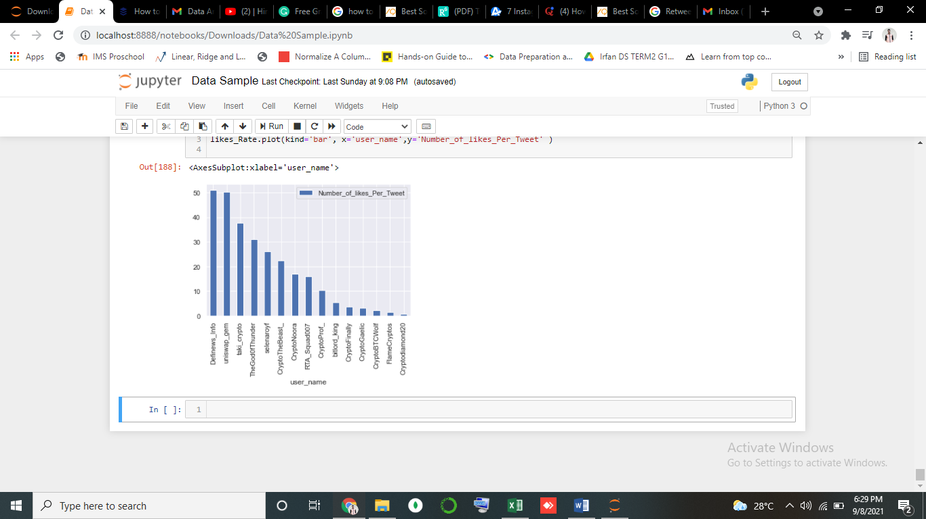

* Method 3 (**Ranking after calculating Engagement of influencers**) :
* So, for ranking the Influencers we use Twitter interaction. To calculate Engagements (**Total number of times a user interacted with a Tweet**).
* Impressions are the number of times your tweet or tweets are seen. E.g, If you have 2,000 followers and you do 3 tweets using a hashtag, that hashtag will get 6,000 potential impressions because of your tweets.
* We can rank Influencers on many different metrics, but we will rank them after taking all different metrics into considerations.
* The best influencers are those who actively interact with their audience.
* Will take few metrics and calculate the Interaction.

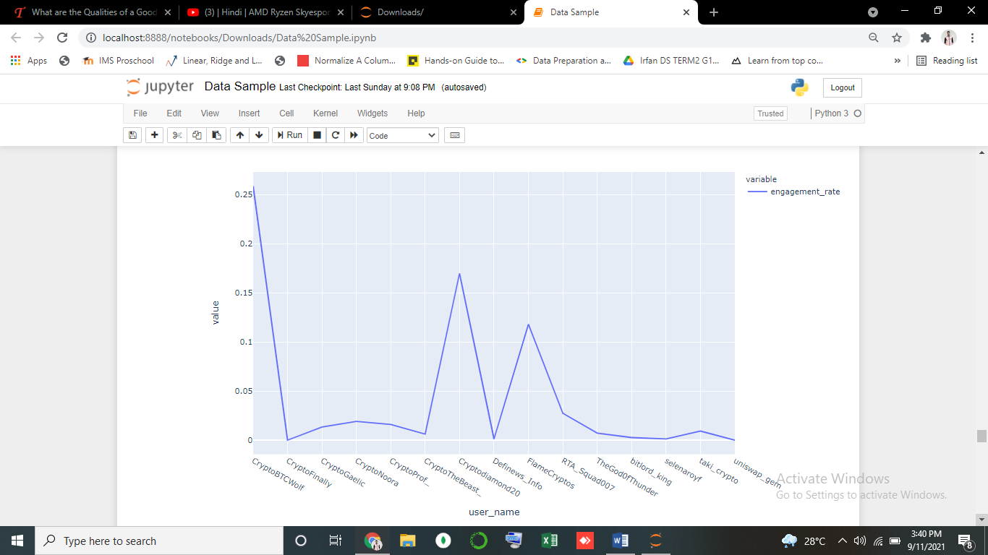

* **What are the different metrics that should be considered while assessing the quality of influencers**?
* For Evaluation of Influencer there are many metrics such as (**no. of Followers, no. of likes of tweets, no. of Retweets, Cost they Charge, no. of Replies, etc.**) that can be considered while evaluating them.
* We check multi variables with numbers to see which influencers rank highest in which categories.
* Below multiple tables show which influencers top in different categories. That can use to Evaluation the influencers.

1. **Follower Number :**

* Not only **does a higher follower count mean more influence in your industry**, but also signals that your audience, leads, and customers are interested in your content.
* According to social media statistics, nearly half of all marketers cite Twitter as their go-to network for engaging with customers.
* Most Brands will also approach the only influencers who have the highest number of followers.

|  |  |  |
| --- | --- | --- |
|  |  |  |
|  |

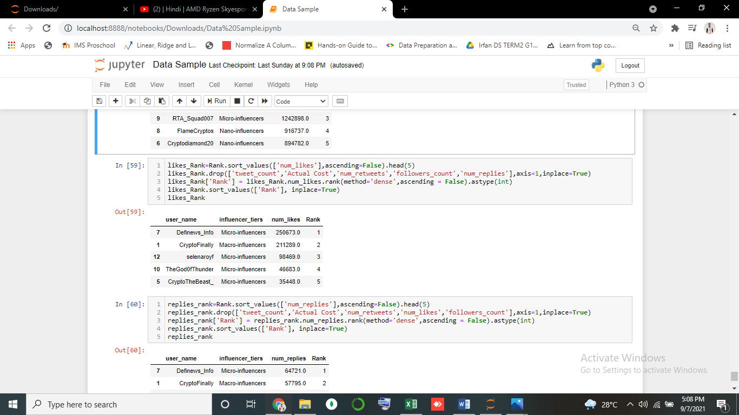 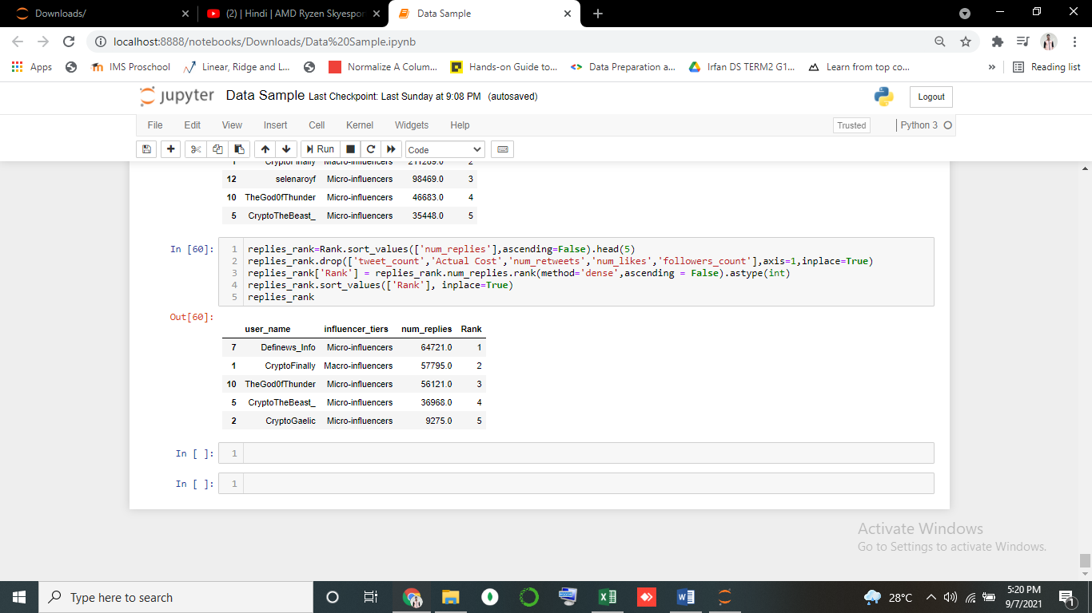 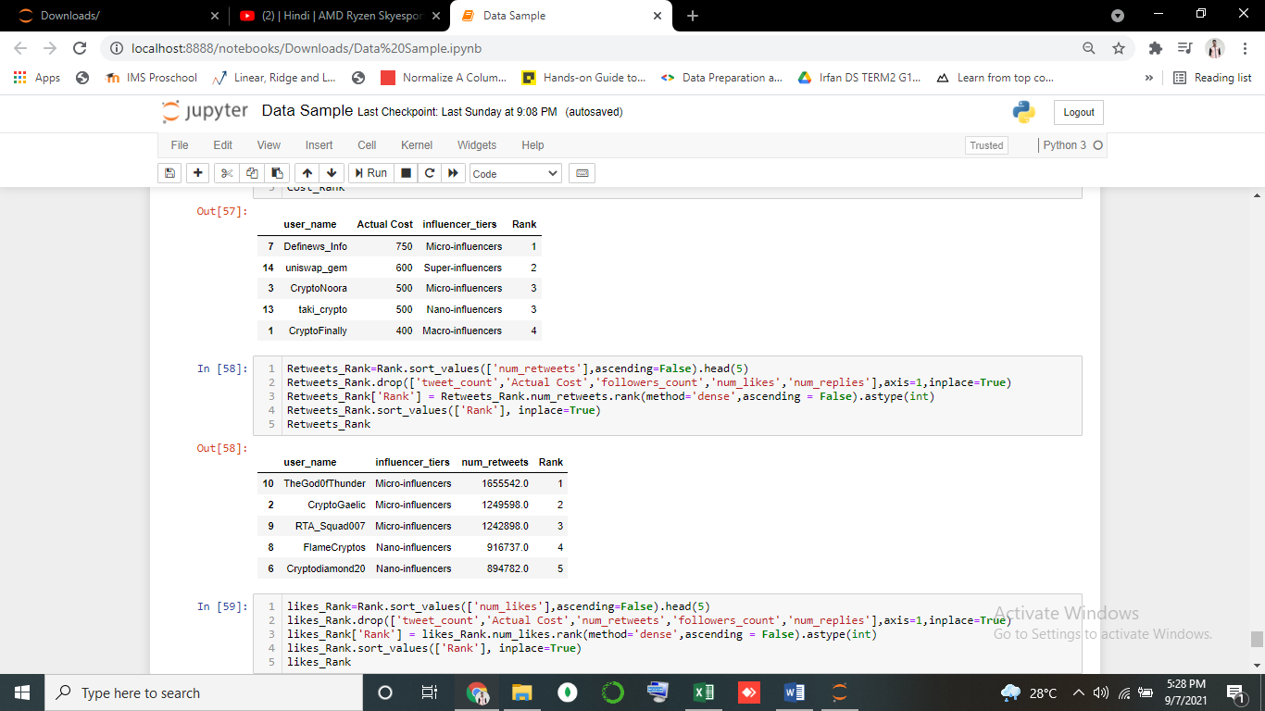

1. **Consistent.**

* Influencers **consistently engage and consequently keep and grow their audience by regularly posting great content**, be it through videos, images, or tweets.
* Upload Good quality of Valuable Content (Engaging, Relevant, Useful/Unique).

1. **Engagements :**

* An influencer’s engagement rate is a ratio representing the degree of commitment between an online audience and the creator’s content.
* A good engagement rate lets you know that the influencer is actively engaged with their followers and that they have respect and interest in their posts and represented brands.
* To measures, Engagement rate is most often measured by the number of interactions and responses to a regular post, including likes, comments, reposts, shares, etc.
* Define the **Total number of times a user interacted with a Tweet.**
* **E.g**

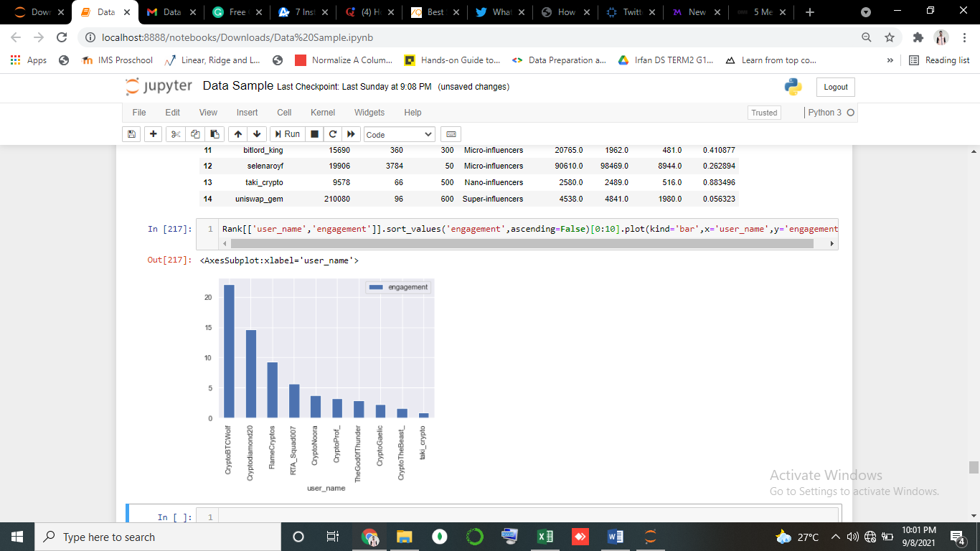

1. **Visibility**

* When you try to introduce a new product or a new brand to the public, one of your main goals should be to grow awareness of the product or brand marketed.
* Regardless of the type of influencer campaign you choose here, it’s important to know what should be measured here and how can you do it better.
* Well, in order to grow awareness, you need exposure. You need visibility. You need to drive traffic to your website or your social media accounts.
* Influencer marketing will help you reach out to the targeted audience, people that are more likely to buy your products or services. Thus, you need to measure some specific analytics data such as the number of visits, the demographic categories, and the average time spent on-site by your visitors.

## **COST EFFECTIVENESS :**

* [Influencer rates vary wildly.](https://blog.carusele.com/how-to-determine-influencer-rates) Over and over we see brands overpaying influencers and not getting a fair rate because they did not do proper due diligence.
* Additionally, when an [influencer works with a manager](https://blog.carusele.com/how-influencer-managers-are-complicating-the-industry), their rate increases significantly, which increases their CPM (cost-per-thousand), and [often this makes them an undesirable partner.](https://blog.carusele.com/update-why-influencers-are-increasingly-walking-away-from-managers)
* When calculating an influencer’s rate, we look at a variety of factors, such as the impressions or clicks we will garner, engagement, the quality of their work, have we worked with them before, and their CPE  (cost-per-engagement) .

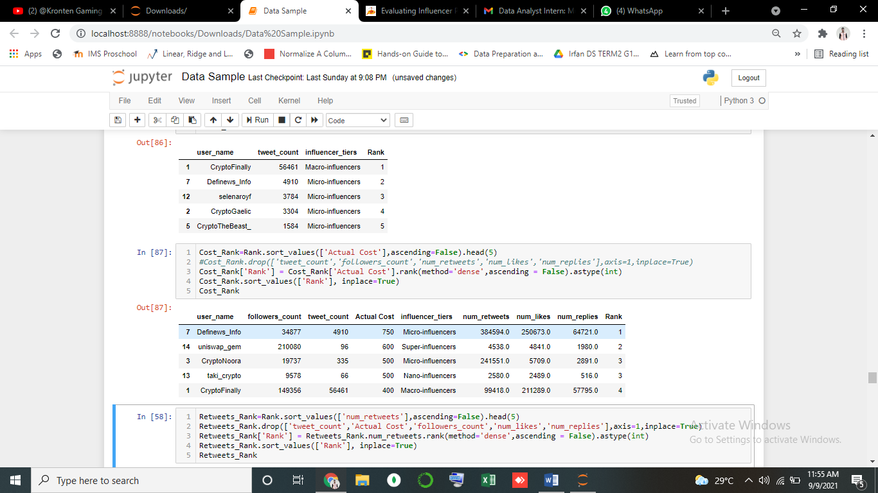

* Above is example of ranking influencers accordingly Cost (they Charge).
* We can conclude that Uniswap_gem (Influencer) have high Followers count compare to others and Charge high, but engagements is less with his/her followers.
* **Design a scoring mechanism to rank the influencers**.
* To Design the Scoring mechanism we take few metric that help to give scores to influencer.
* We give score on how influencers engagements rate.
* The engagement rate is a metric used to gauge the level of engagement generated from created content or a brand campaign. In other words, the engagement rate refers to the level of interaction with followers that is generated from content created by a Influencers.

Number if Likes on Post

+ Total no. Total Engagement (score) = Total no. of Interaction × 100

Number of Retweets on Post = of Total no. of Impression

Interaction

+

Number of Replies on Post

Follower counts Total no. of

× = Impression

Tweets Counts

1. **Total no. of Interaction**

* For Influencers, Quality of number of Post is one of the main metric, if Follower like that post they will Replies, Retweets, Likes, shares.
* This will help them to growth their influence & attract multiple small Brands for Campaign there Products.
* To Calculate Total no. Interaction. We take Total no. of Likes, Total no. of Retweets, Total no. Replies and Add them to get Interaction values.

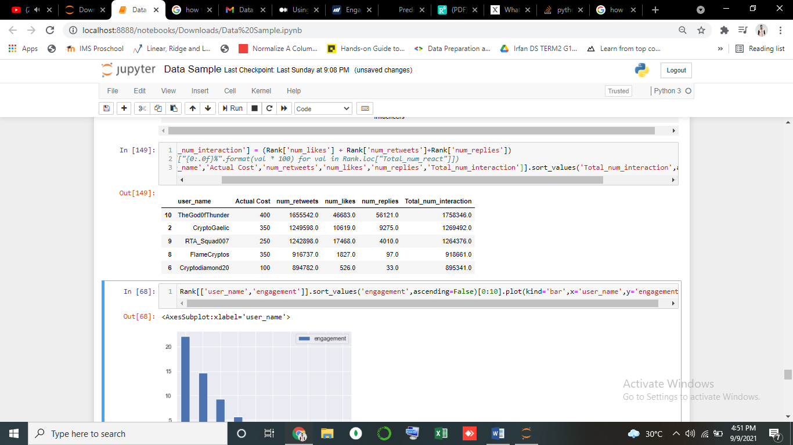

* Above table tell TheGodOfThunder and CryptoGaelic have better interaction on his/her post and Cost is also not high.

1. **Impression**

* A tweet impression is generated when anyone sees our tweet.
* This impressions are available in the Twitter Analytics section of our Twitter profile and it is available only for the owner of the account. We cannot see the impressions of other people.
* To calculate Impression number of followers of the users who sent tweets and the number of tweets they sent

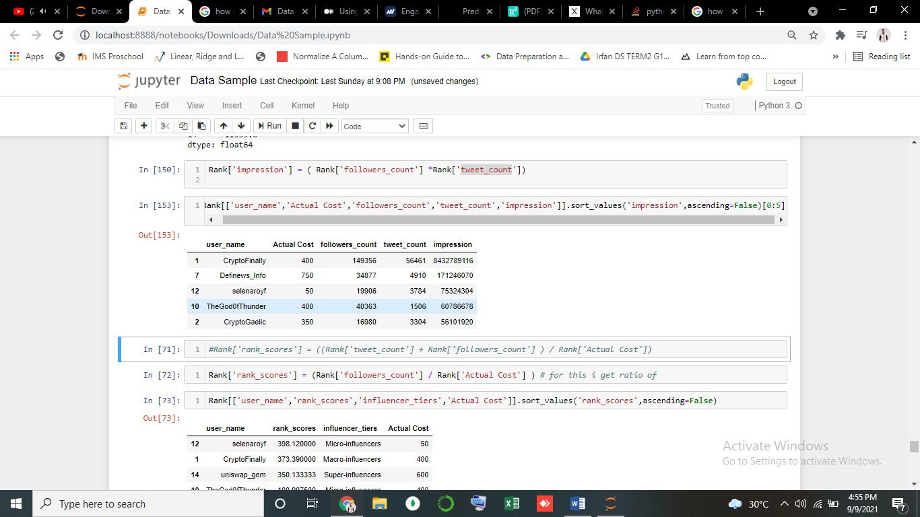

1. **Total Engagements (Creating Scoring to give rank to influencers).**

* Engagement rate is a**formula that measures the amount of interaction social content earns relative to reach or other audience figures**. This can include reactions, likes, comments, direct messages, mentions, click-throughs and more.
* **Define :The number of interactions divided by actual impression.**

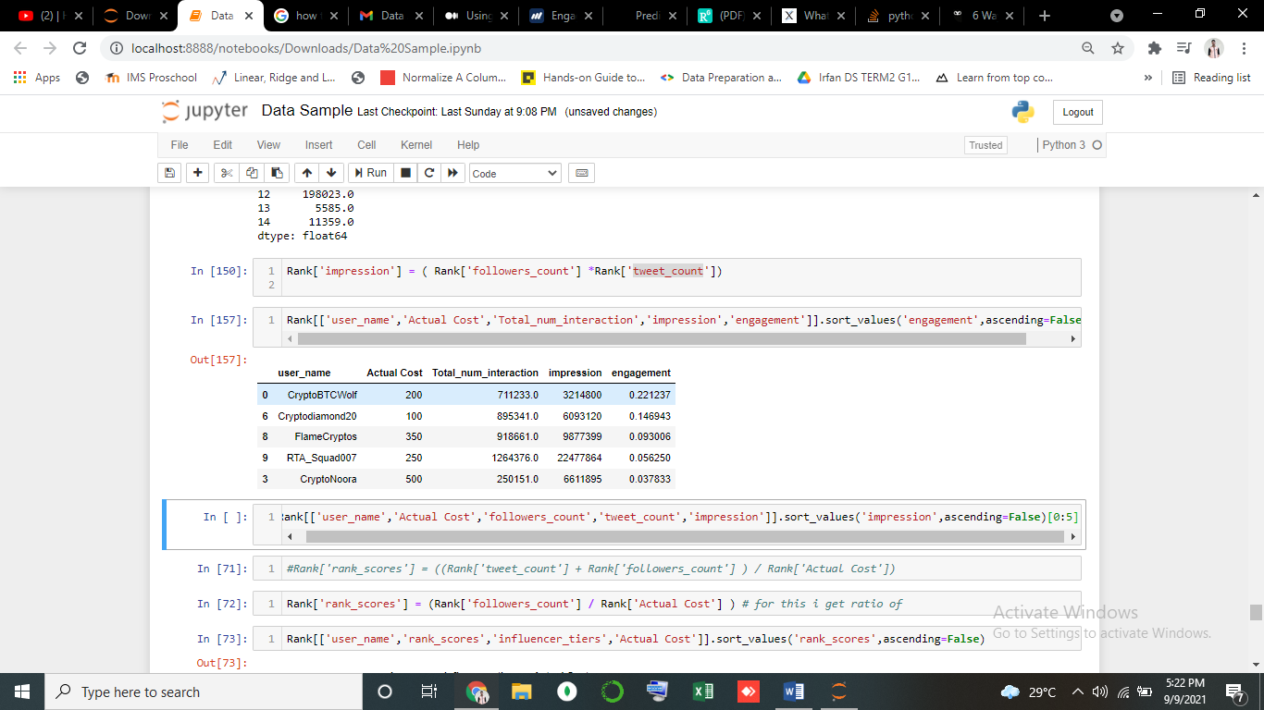

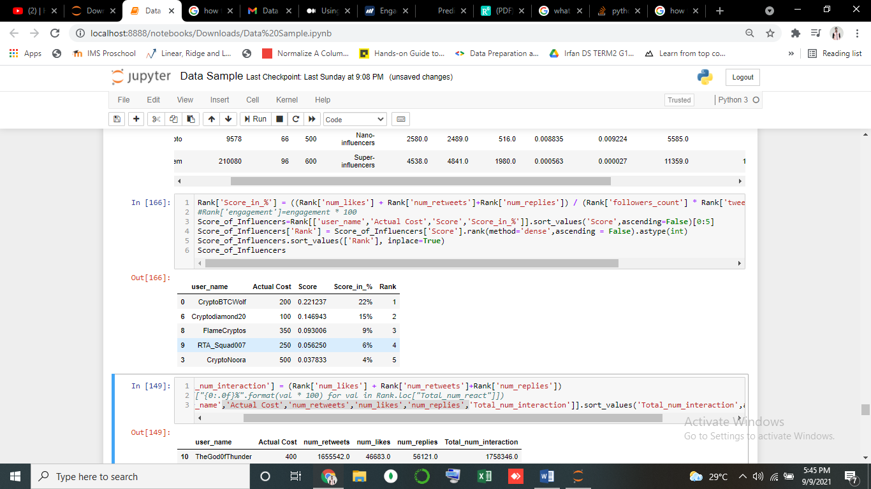

* With this we will get to know which have well Engagement with their post & followers.
* We have Created Scoring System to rank the Influencers based on their Social Engagements.
* As we see in above table, it conclude that CryptoBTCWolf more active on his social account and consistently interact with his followers
* **Given the pricing, design a campaign which will minimize the cost per 1000 followers.**
* In basics, we have to select the influencers so that we have minimized the cost per 1000 followers once we have determined which influencers we want to use for the campaign.
* Twitter 2$ per/1000 followers
* Let select top influencers from above table which we create using a scoring mechanism.

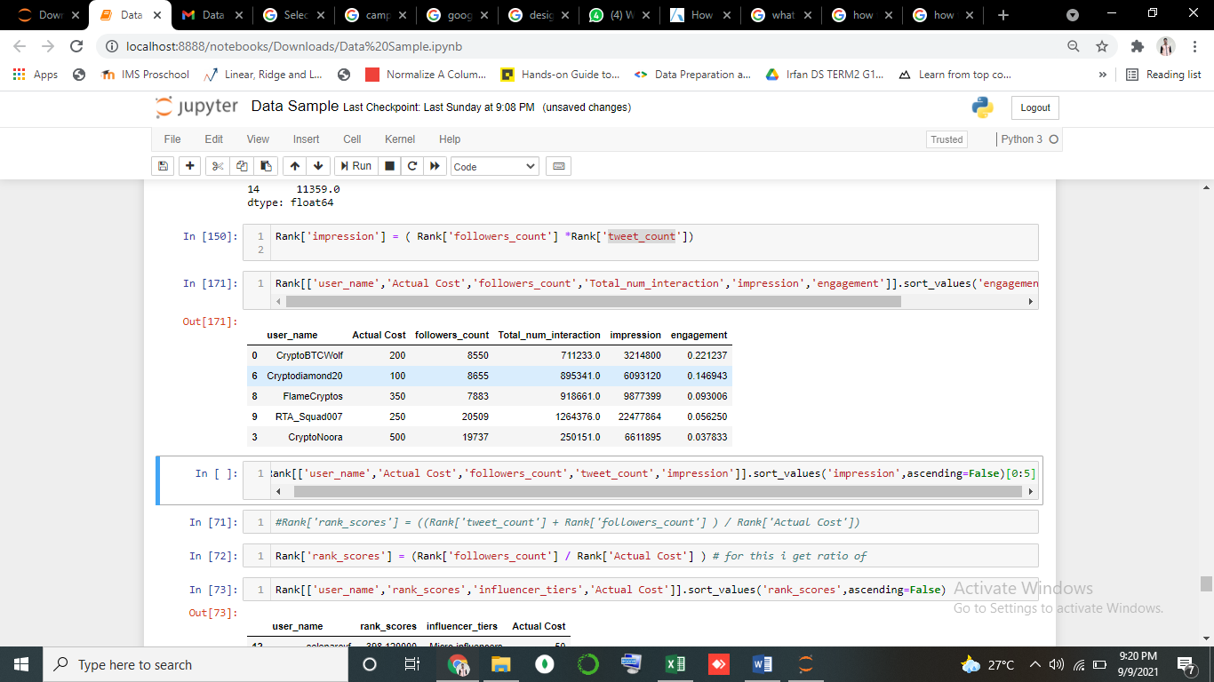

* As we Know Bigger the influencers, the more followers they have, so as for marketing influencers charge money based on Followers.
* It will over-pricing and lost for brands.

**How Do You Calculate Cost Per Thousand?**

* To calculate the cost per thousand, multiply the cost by 1,000, and divide by the target audience. Interpret the result.

1. **Determine the values**

* Find the cost and the target audience totals. The cost means the cost of producing the advertisement. The target audience total varies based on the type of media.
* The cost per thousand is calculated for a printed page or broadcast time. For print media, when the audience data is not available, use the circulation number.
* When it is available, use the number of prospects reached. For broadcast media, use the number of homes reached by a given program or time period. The target audience can also be readers or the number of audience members of any kind of demographic or product usage classification.

1. **Multiply the cost by 1,000**

* Multiply the cost of the campaign by 1,000.

1. **Divide by the target audience**

* Divide the result by the number of the target audience. For example, cost per thousand = 200,000/8550 people =23.5. The cost per thousand is $23.5

1. **Interpret the result**

* The lowest cost per thousand is the most efficient ad campaign, assuming all other variables are equal. Often, the media with the lowest cost per thousand is the one that is picked.

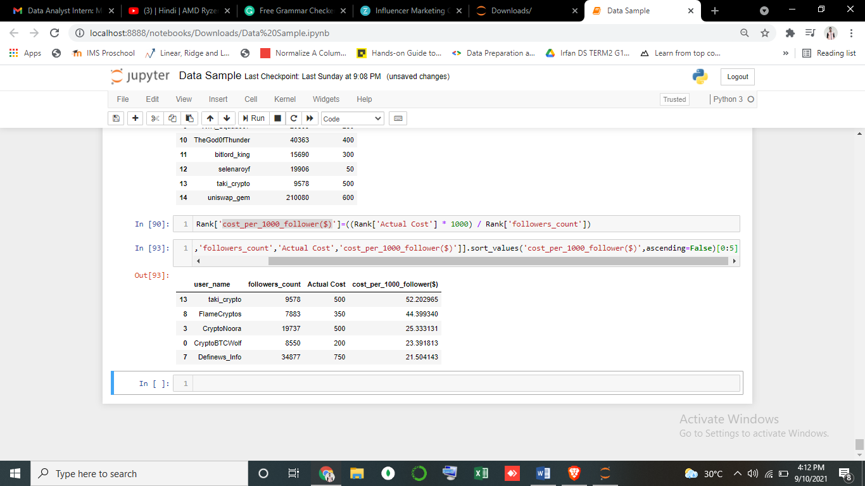

* **Campaign**

### Choose Business Objectives

* **Select Nano and Mirco influencers**
* For saving cost per 1000 followers, we will use those influencers who have fewer followers and help to reduce the cost per 1000 followers and their engagements are better than Marco, Mega- influencers.
* The number one thing to look at when pricing influencer marketing costs is followers. Generally, influencers with large followings get paid more, because they reach more people.
* Nano -influencers: Less than 10,000 followers
* Micro-influencers: 10,000 to 100,000 followers
* **Use of More Hashtags**
* Its reach more audience which is not followers
* **Target a more specific audience.**
* **Demand and seasonality:**
* If influencer of choice is being targeted by several brands, they are in a position to increase their prices. And if you're wanting to work with them at a time of year where demand is greatest (e.g. around Christmas), then this will also push the cost up.
* So hired them before there cost goes high.
* **Allocate/ Negotiations a Budget**
* **What changes will you make to the above campaign if quality of influencers is also taken into account?**
* **Followers**
* Influencers with huge followings aren’t necessarily the right ones to work with either. It depends on your goals, and whether the influencers’ audience is relevant. It’s more important to select influencers whose followers will be interested in your product or brand!
* For many businesses, working with micro- or nano-influencers from the correct niche can be more cost-effective for their marketing budgets. Influencers with a smaller following generally cost less. They’re also often more flexible in the amount and type of content they’re willing to create.
* **Engagement**
* Second, you want to look at engagement. Influencers with higher engagement show that they have an engaged audience who’s more likely to interact with branded content they share.
* Because of this, they’ll charge a higher price compared to other influencers of the same size.
* When you’re selecting influencers to work with, compare their engagement rate to our benchmarks below. Generally, small accounts will have higher engagement. Engagement drops as accounts grow.

* **Campaign / Impression**
* A tweet impression is generated when anyone sees our tweet.
* The complexity of the campaign will also impact influencer marketing costs. Generally, the more complex the campaign, the greater the cost.
* Here are a couple things to keep in mind:
* Videos require more work and time to produce, so they’ll cost more than images.
* A series of posts, like Instagram carousel posts, will typically cost more than a single post.
* A full review or endorsement on a blog tends to cost more than a simple photo with your product.
* **Change in campaign if quality of influencers is also taken into account**
* # should Post or promote more than once on social account it help reach to more people.
* # Consistent in making good quality of content.
* #Influencers Increase Content Reach and Engagement.
* **Extra Analysis**

1. **Creating Tier for influencer**

* We can see different influencer that rank highest with using different variables.
* We also assign tiers to the influencers like Nano-influencers, Mirco-influencers, Macro-influencers, Mid-tier influencers, super-influencers.

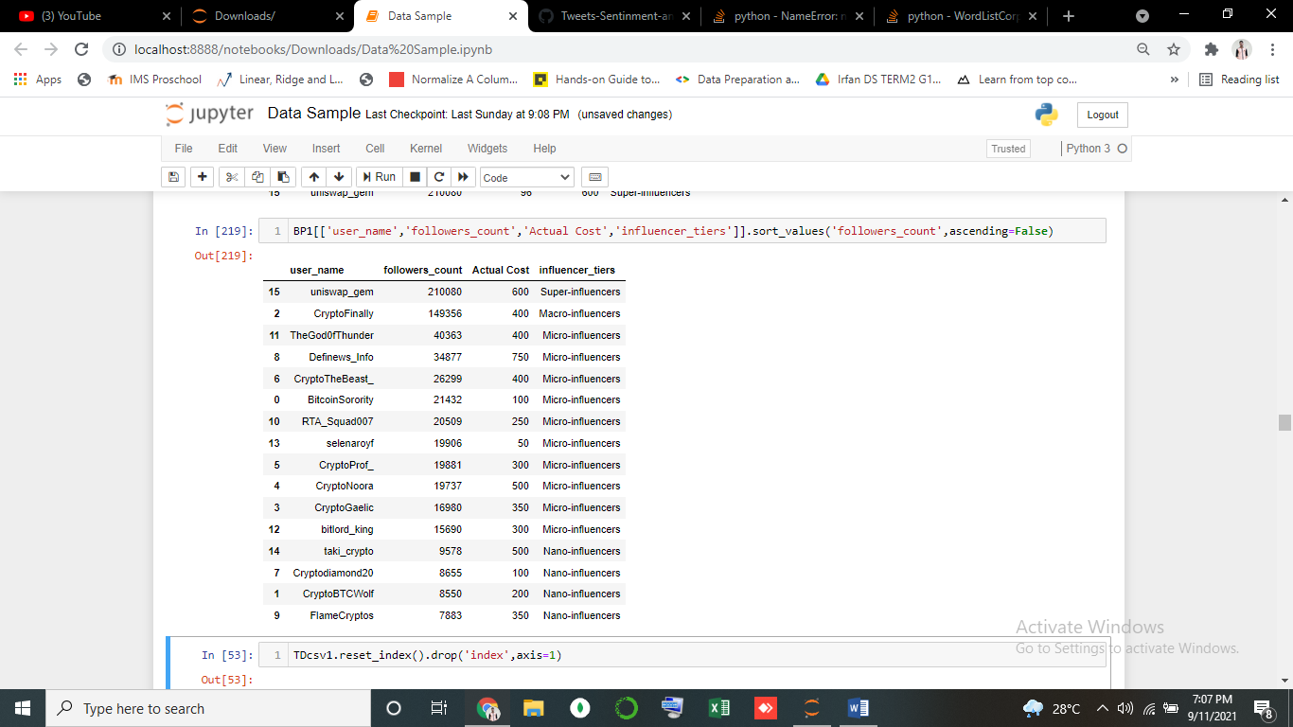

* This will help to identified the influencer based on Tier.

1. **Analyzing top 2 influencer tweets**

* We have already created scoring system, from that we take top 2 influencers
* 1) CryptoBTCWolf

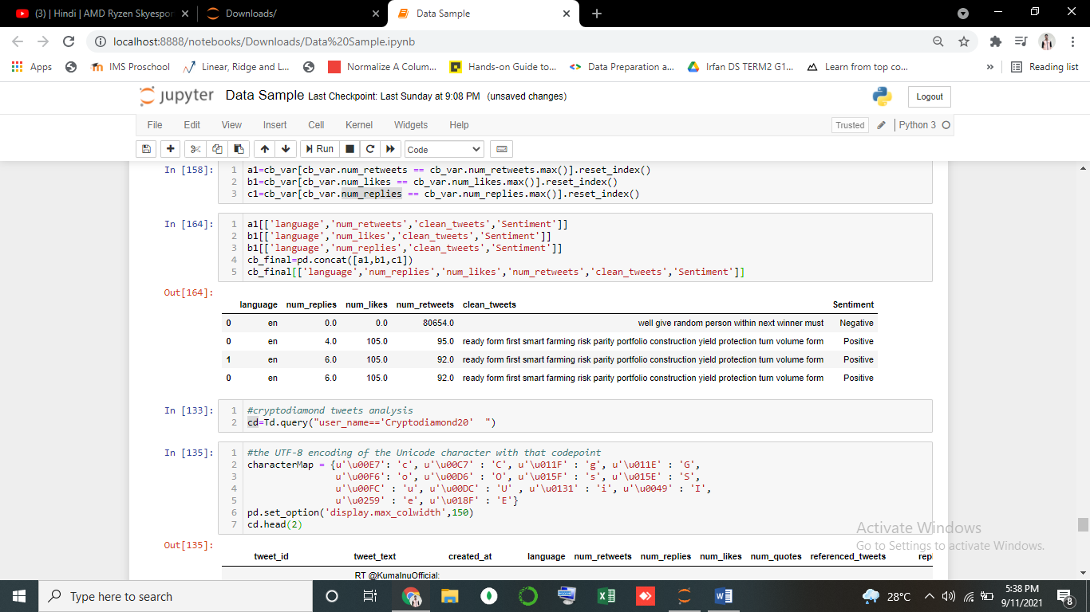

* We can tell on which tweets CryptoBTCWolf get more engagements and also sentiment of that tweets written in which language.
* Before analyzing this tweets we have clean this tweets with helps of NLP package in python, so we can perform analysis on its.
* We can check which words influencers use frequently in his tweets.

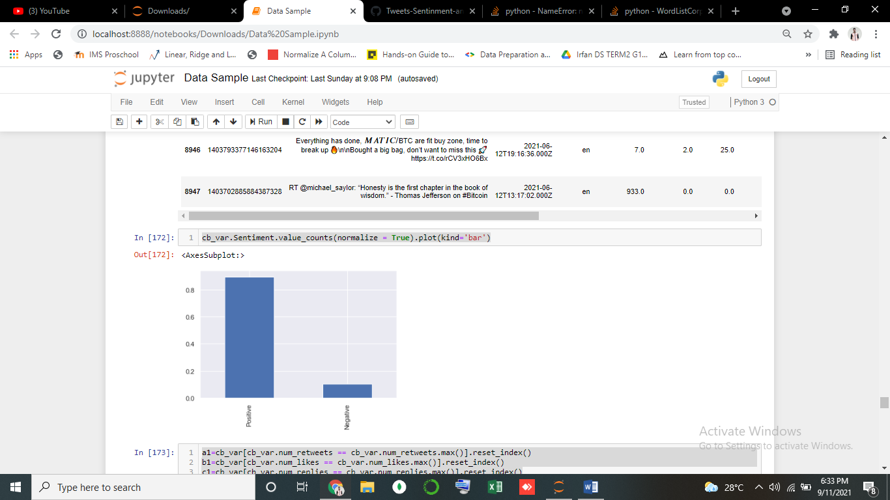

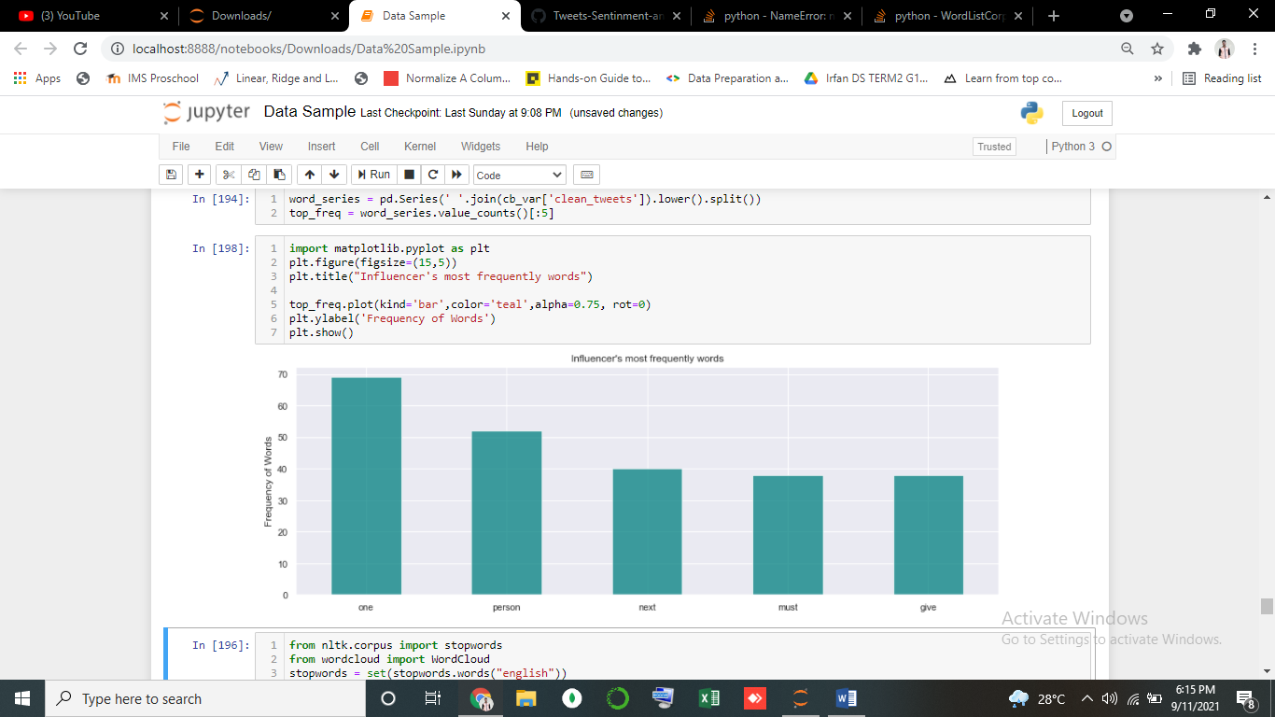

* “One” and ‘Person’ words is most use by CryptoBTCWolf.
* Lets see wordscloud.

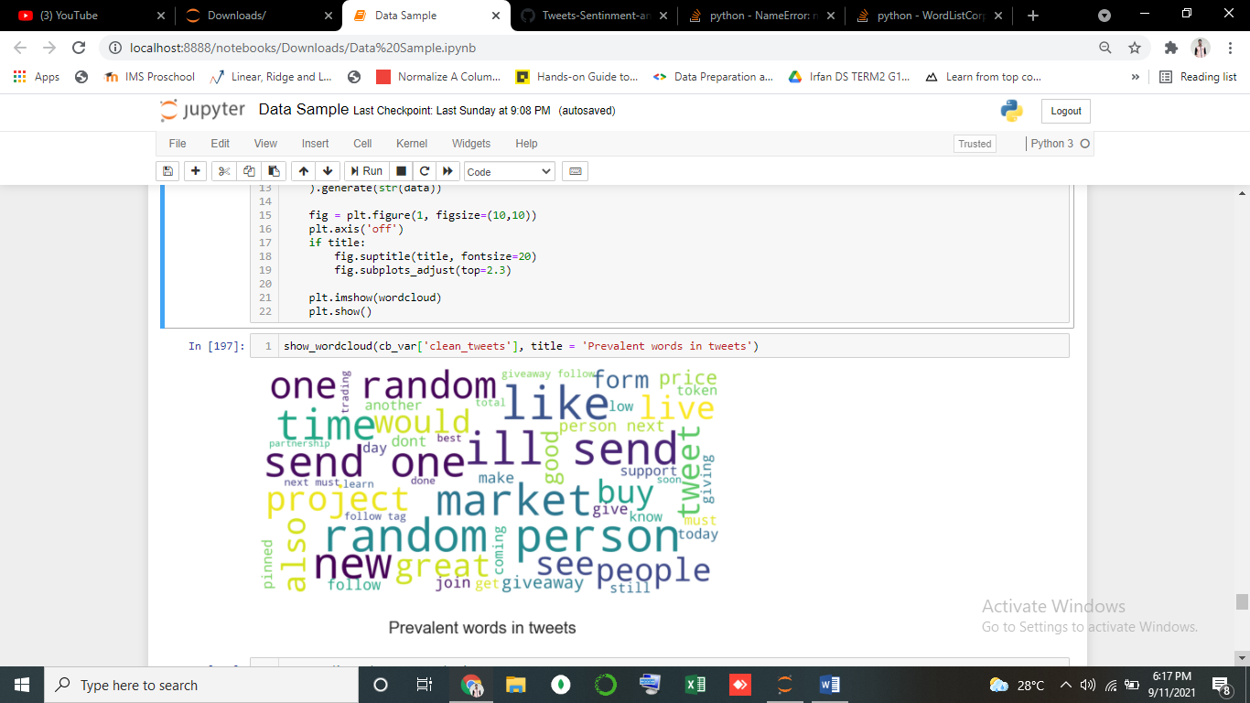

* We can also see what type of content this influencer posted or used hashtags.
* By separate hashtags from tweets using extractall method and regex.

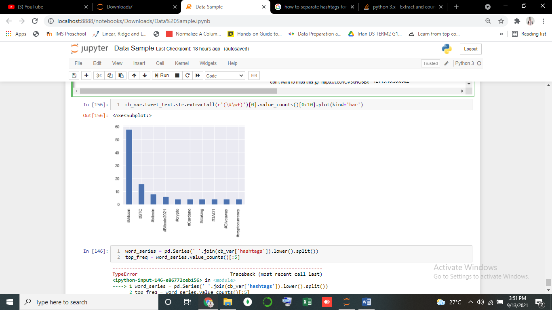

* He tweets more about Crypto currency and Bitcoin.

🡺 Second Influencers “**Cryptodiamond20”.**

* Most number of like, replies and retweets on tweets done by influencer.

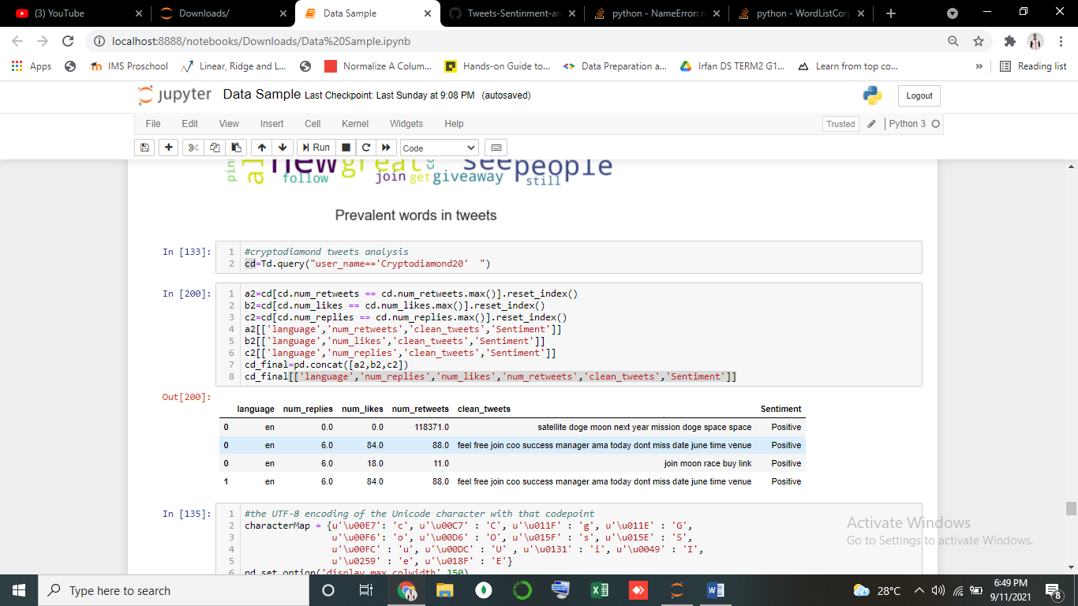

* Percentage sentiment of Tweets.

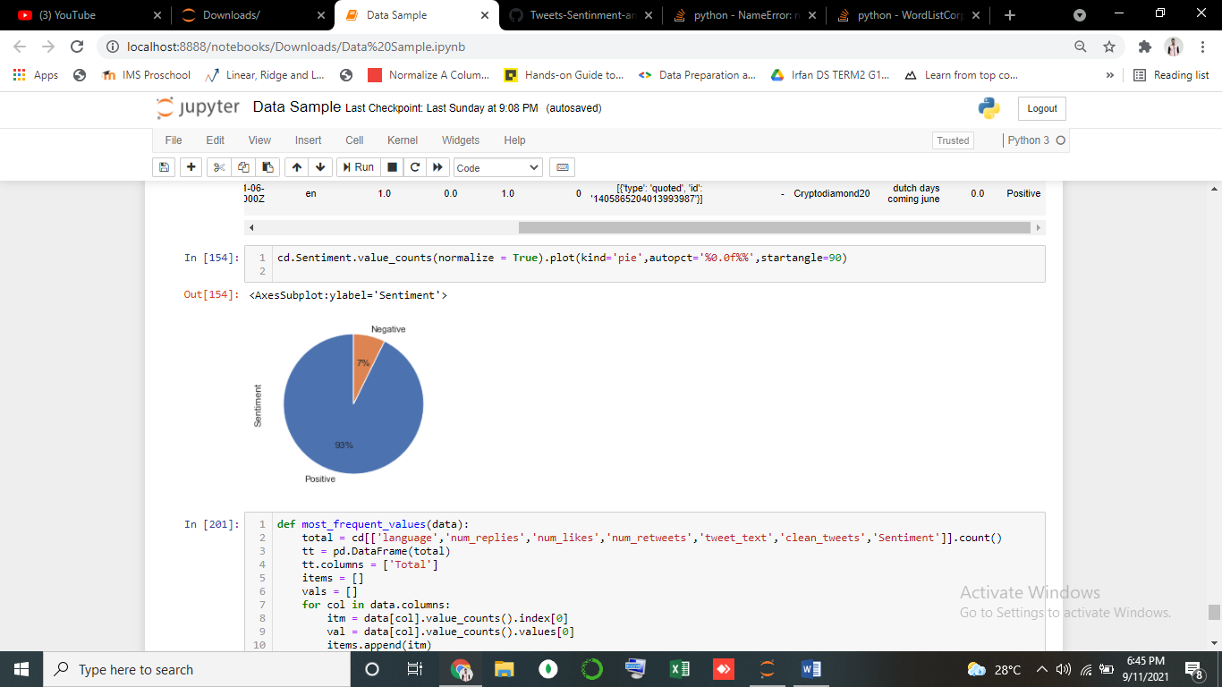

* Most Words tweets by Influencer.

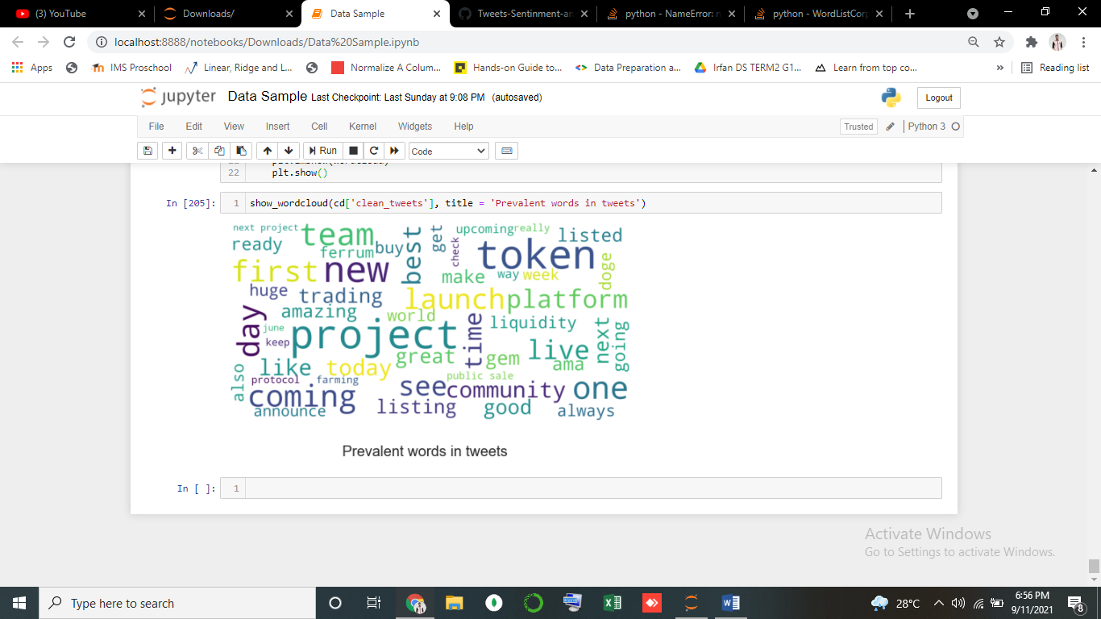

* For same we see which hashtags to use by influencers.

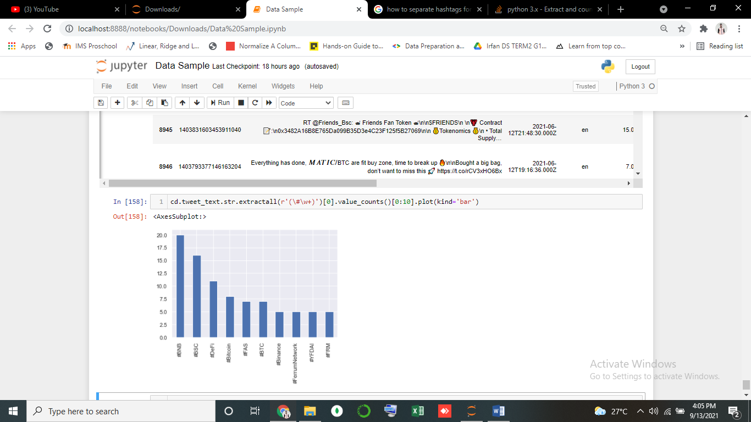

* #BNB hashtag use more by **Cryptodiamond20**
* **We used this to more hashtags use by different influencers.**